|  |  |
| --- | --- |
| **Name:- Aryan Dilipbhai Langhanoja** | **Roll Number:- 92200133030** |
| **Subject Name and Code:-** Foundation Skills On Sensor Interfacing (01CT1103) | **Date of Experiment:- 13-01-2023** |

|  |  |
| --- | --- |
| Task:- |  |

# Character analysis using string.

|  |  |
| --- | --- |
| About the Project:- |  |

* In thisproject, we learning Character Analysis using strings.

|  |  |
| --- | --- |
| Code:- |  |

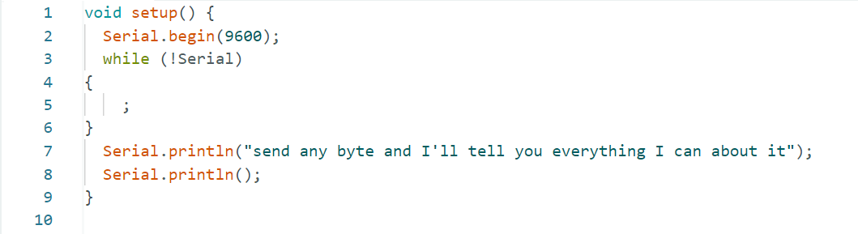

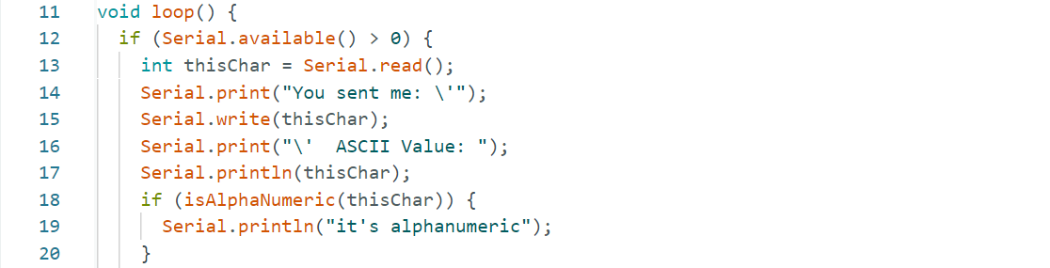

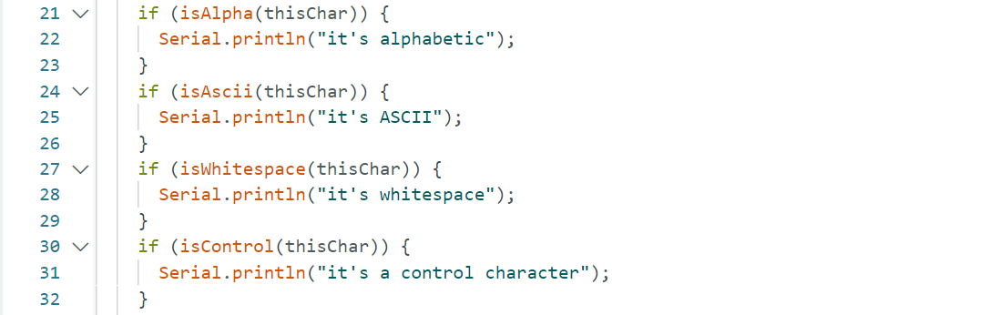

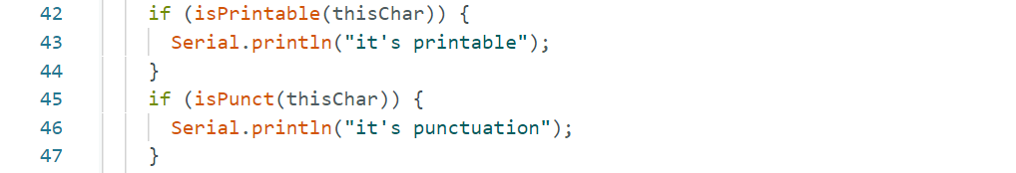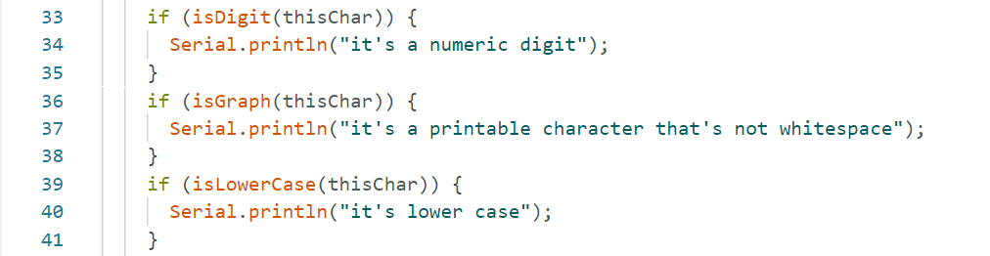

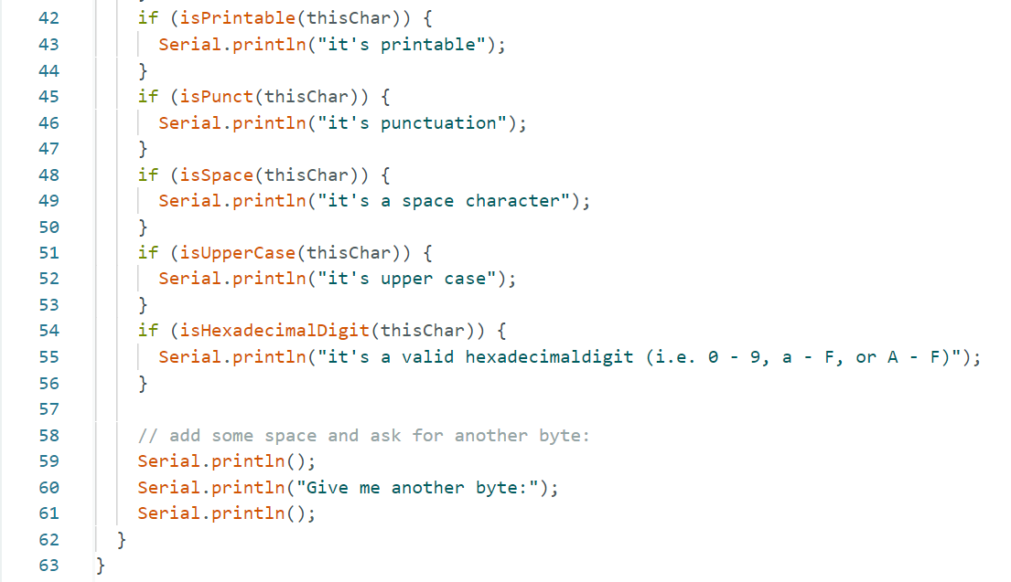

|  |  |
| --- | --- |
| Conclusion:- |  |

* In This Experiment, We Learnt Character analysis using functions.